1. **Simple Form**: This type of portlet contains a form that allows users to input data, which can then be processed or submitted. It typically includes form elements like text fields, checkboxes, and buttons.

/**

* @NApiVersion 2.1

* @NScriptType Portlet

*/

define(['N/ui/serverWidget'],

/**

* @param{serverWidget} serverWidget

*/

function (serverWidget) {

//Simple Form, Inline HTML, Links and Indents, Simple List

const render = (params) => {

var myPortletObj = params.portlet

myPortletObj.title = 'My Portlet'

//Simple Form

myPortletObj.addField({

id: 'custpage_name',

label: 'Enter Name',

type: serverWidget.FieldType.TEXT

})

myPortletObj.setSubmitButton({

url: '<https://hsg15.github.io/lucky/>',

label: 'Save'

})

}

return {render}

});

While uploading the code by navigating to Customization -> Scripting -> Scripts -> New, make sure to select the PORTLET TYPE.

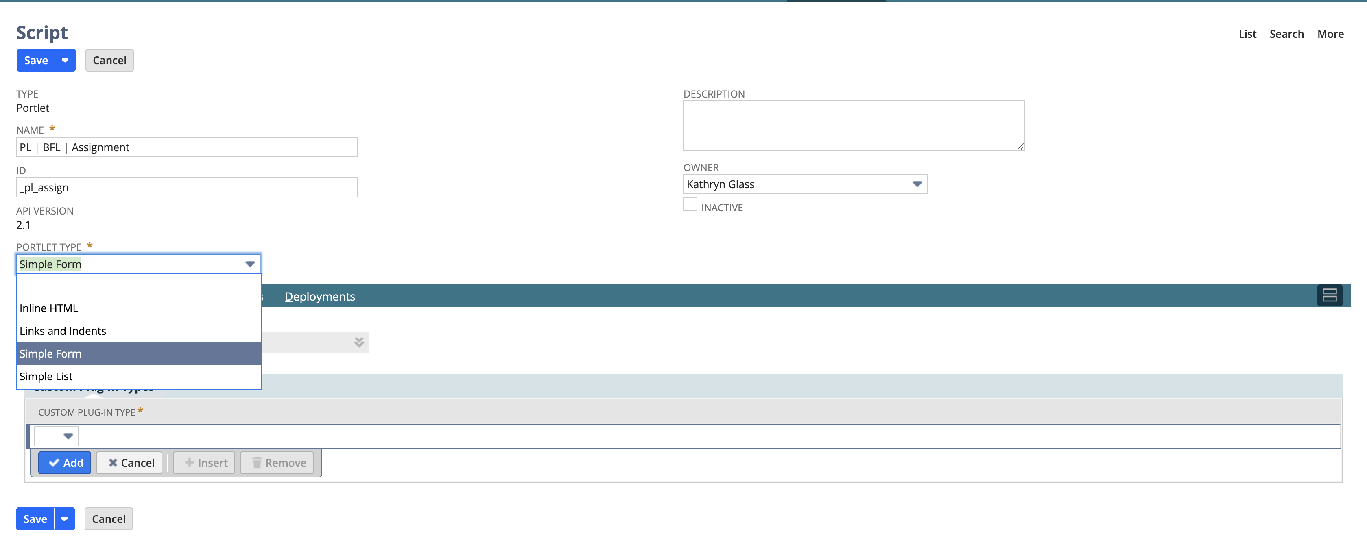 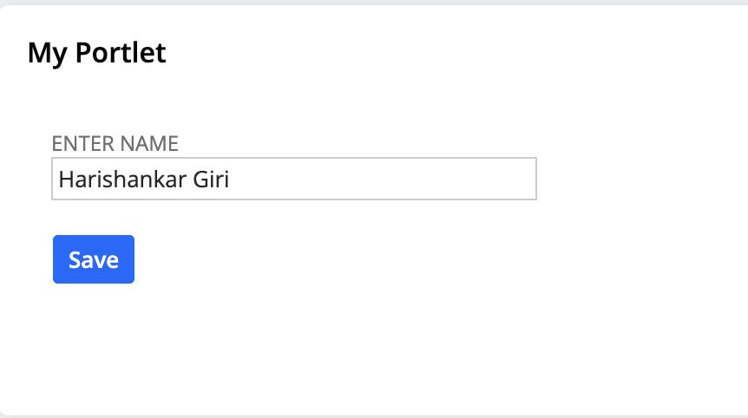

1. **Inline HTML**: An **Inline HTML** portlet displays custom HTML content directly within the portlet. It allows the portal designer to add rich, formatted text, images, or other HTML components for customization.

const render = (params) => {

var myPortletObj = params.portlet

myPortletObj.title = 'My Portlet'

// Inline HTML

var inlineHTMLField = myPortletObj.addField({

id: 'divfield',

type: 'inlinehtml',

label: 'Test inline HTML'

});

inlineHTMLField.defaultValue =

'<div id="divfield_elem" style="border: 1px dotted black; height:150px; width:150px;">' +

'<img src="https://encrypted-tbn0.gstatic.com/images?q=tbn:ANd9GcQ0qjaY1Si6xgGYzbsrgMCnGdumxOmYMCwhzw&s" ' +

'alt="Sample Image" style="height: 100%; width: 100%;" />' +

'</div>' +

'<p style="margin-top: 10px; text-align:center;">Harishankar Giri</p>';

myPortletObj.addLine({

text: 'Harishankar Giri'

})

}



1. **Links and Indents**: This portlet presents a structured list of hyperlinks, often with indented items to represent a hierarchy or nested list. It’s useful for navigation menus or lists of resources.

const render = (params) => {

var myPortletObj = params.portlet

myPortletObj.title = 'Links & Indents'

// Links and Indents

var inlineHTMLField = myPortletObj.addField({

id: 'linksfield',

type: serverWidget.FieldType.INLINEHTML,

label: 'Links and Indents'

});

var linksHTML =

'<div>' +

'<a href="https://hsg15.github.io/lucky/" target="_blank">My Portfolio</a><br><br>' +

'<a href="https://www.linkedin.com/in/hsg15/" target="_blank">My LinkedIn</a><br><br>' +

'<a href="https://github.com/HSG15" target="_blank">My GitHub</a><br>' +

'</div>';

inlineHTMLField.defaultValue = linksHTML;

}



1. **Simple List**: This portlet shows a basic, unordered or ordered list of items, such as text entries or links. It is commonly used to display simple, structured data in a straightforward manner.

const render = (params) => {

var myPortletObj = params.portlet

myPortletObj.title = 'Simple List'

// Simple List

var simpleListField = myPortletObj.addField({

id: 'simplelistfield',

type: serverWidget.FieldType.INLINEHTML,

label: 'Simple List'

})

var simpleListHTML =

'<ul>' +

'<li>Item 1</li>' +

'<li>Item 2</li>' +

'<li>Item 3</li>' +

'</ul>';

simpleListField.defaultValue = simpleListHTML

}

